**Second Task:**

Create a file with .txt extension (/home/demo.txt).

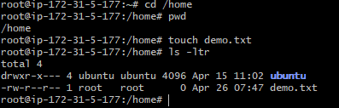

Change the permission set of that file, so that any user can read it, group can read/write & owner can read/write/execute it.

By giving **764 permission** to that file

Owner having full permission of read (4) write (2) execute (1) = 7

Group having read (4) & write (2) = 6

Other or Any user having only read(4) =4

